BUSINESS PROBLEM
The company aims to increase overall chocolate sales by 15–20% in the next financial year by identifying high-growth products, underperforming regions, and sales inefficiencies. Using historical sales data, the analysis will uncover actionable insights to optimize product focus, regional strategy, and salesforce effectiveness.
Analysis Goals:
Goal 1: Measure Overall Business Performance
- Purpose: Track progress toward the 15–20% growth target.
Goal 2: Identify Revenue-Driving Products
- Purpose: Focus marketing and inventory on products that can scale revenue fastest.
Goal 3: Evaluate Sales Person Effectiveness
- Purpose: Detect high performers and sales inefficiencies impacting growth.
Goal 4: Analyze Country-wise Sales Strength & Weakness
- Purpose: Identify regions contributing most/least to growth targets.
Goal 5: Understand Seasonal & Time-Based Trends
- Purpose: Align promotions and inventory with peak sales periods.
Goal 6: Measure Sales Efficiency
- Purpose: Determine whether higher shipment volumes actually drive higher revenue.
Goal 7: Product Performance by Season
- Purpose: Identify which chocolate products perform best in specific seasons to maximize targeted sales growth.
Goal 8: Identify Underperforming Markets with High Effort
- Purpose: Spot salespersons shipping high volumes but generating low revenue, key optimization opportunity.

SQL Queries Results
  - Total & Average Sales (Overall Business Health) (Helps benchmark current performance before targeting 15–20% growth)
Query: Select SUM(Amount) as Total_Sales,
Avg(Amount) as Avg_Sales
From ChocolateSales;
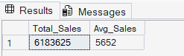
  - Total Boxes Shipped (Shows operational scale and demand volume)
Query: SELECT
SUM(Boxes_Shipped) AS TotalBoxes
FROM ChocolateSales;
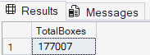
  - Sales by Country (Helps understand regional performance, growth opportunities, and weak markets)
Query: SELECT
Country,
SUM(Amount) AS Country_Sales
FROM ChocolateSales
GROUP BY Country
ORDER BY Country_Sales DESC;
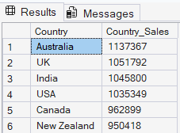
  - Sales Person Performance (Identifies top performers and highlights salesforce inefficiencies by revenue and volume)
Query: SELECT
Sales_Person,
SUM(Amount) AS Total_Sales,
SUM(Boxes_Shipped) AS Total_Boxes,
AVG(Amount) AS Avg_Sale_Value
FROM ChocolateSales
GROUP BY Sales_Person
ORDER BY Total_Sales DESC;Select Top 15 CustomerID, Sum(TotalAmount) as LifeTimeValue, Count (*) as PurchaseCount
from RetailData
Group by CustomerID
Order by LifeTimeValue DESC;
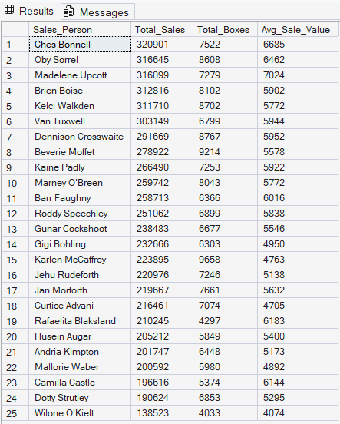

  - Sales Efficiency by Country (Reveals whether shipment effort is converting into revenue, critical for optimization)
Query: SELECT
Country,
SUM(Amount) AS Total_Sales,
SUM(Boxes_Shipped) AS Total_Boxes,
ROUND(SUM(Amount) / SUM(Boxes_Shipped), 2) AS Sales_Per_Box
FROM ChocolateSales
GROUP BY Country
ORDER BY Sales_Per_Box DESC;
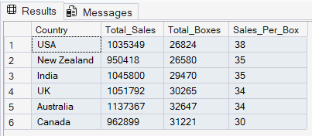
  - Monthly Sales Trend with Growth Indicator (Supports seasonality analysis and tracks momentum toward growth target)
Query: SELECT
FORMAT(Date, 'yyyy-MM') AS Sales_month,
SUM(Amount) AS Monthly_sales,
LAG(SUM(Amount)) OVER (
ORDER BY FORMAT(Date, 'yyyy-MM')
) AS Previous_month_sales,
SUM(Amount)
- LAG(SUM(Amount)) OVER (
ORDER BY FORMAT(Date, 'yyyy-MM')
) AS Change_vs_Previous_month
FROM ChocolateSales
GROUP BY FORMAT(Date, 'yyyy-MM')
ORDER BY Sales_month;
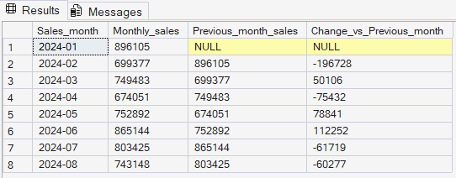

Dashboard Overview

Dashboard 1: Company Performance Overview
Key Visuals:
- KPI Cards: Total Sales, Average Sale Value, Total Boxes Shipped
- Product-wise Sales (Bar Chart)
- Country-wise Sales (Column Chart)
- Monthly Sales Trend (Line Chart)
Insights:
- Identifies top revenue-driving products
- Highlights strongest and weakest markets
- Establishes baseline performance for growth tracking
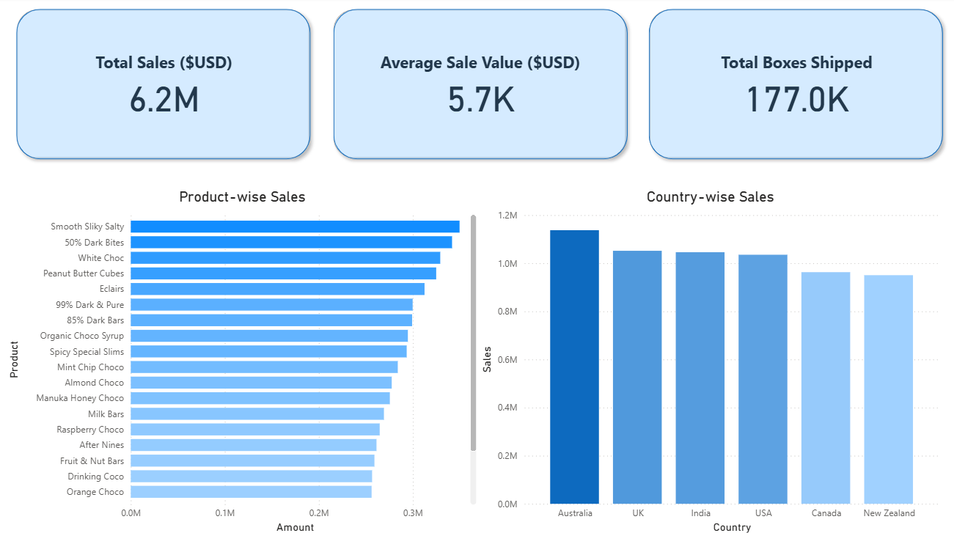

Dashboard 2: Sales & Performance Analysis
Focus: Sales manager insights
Key Visuals:
- Sales Person Performance Table
- Monthly Sales Trend (detailed view)
- Interactive slicers (Country, Product, Quarter)
Insights:
- Reveals performance differences among salespersons
- Supports targeted coaching and incentive planning
- Connects individual performance with overall trends
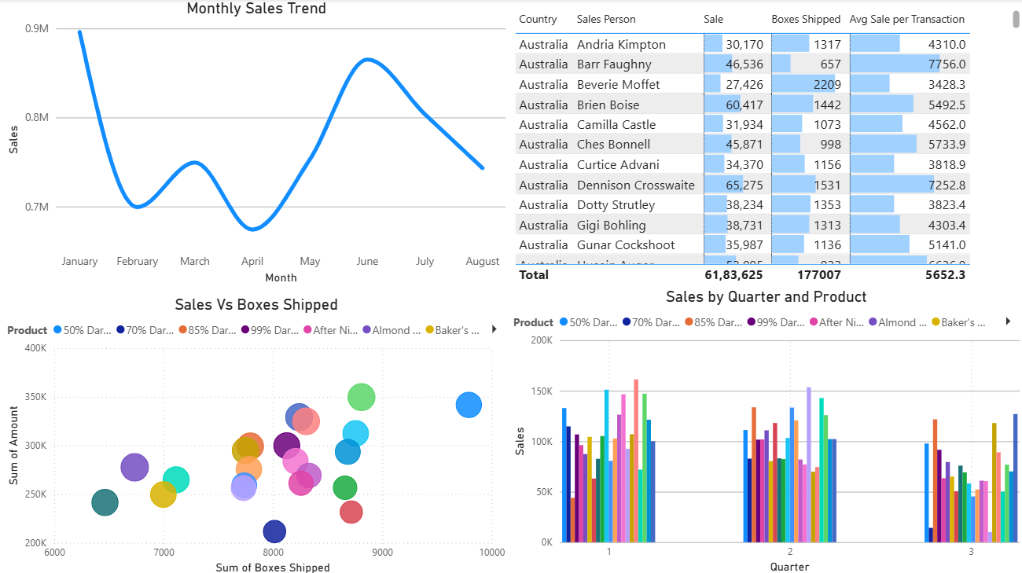

Dashboard 3: Efficiency & Optimization
Focus: Strategy and optimization
Key Visuals:
- Sales Efficiency Scatter Plot (Sales vs Boxes Shipped with reference lines)
- Sales Efficiency Summary Table
Insights:
- Identifies high-effort, low-return sales patterns
- Highlights best-performing salespersons for scaling
- Enables optimization without increasing shipment volume
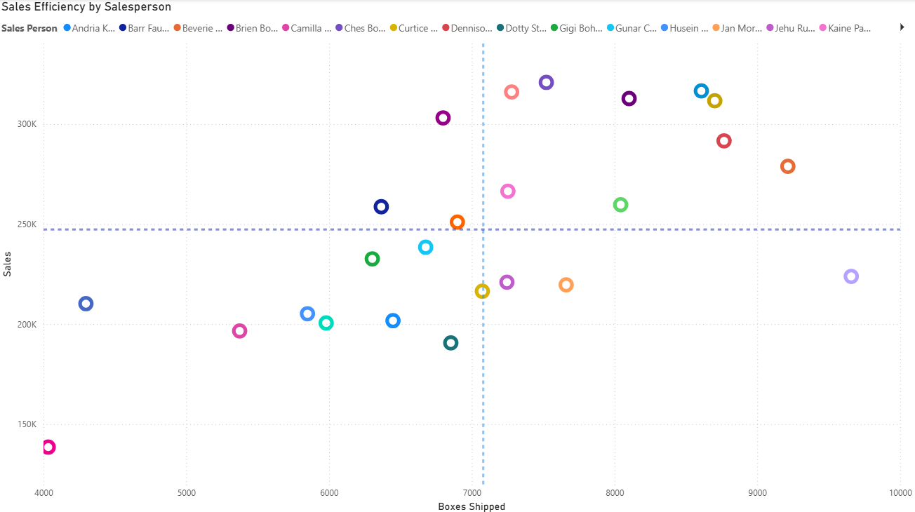

Key Business Insights:
- A small group of products contributes the majority of revenue, presenting strong opportunities for focused growth.
- Sales performance is geographically concentrated, with certain regions outperforming others.
- Clear seasonality exists, making timing of promotions critical.
- Sales efficiency varies significantly across salespersons, indicating opportunities for optimization and best-practice sharing.

Business Impact:
By acting on these insights, the company can:
- Optimize product and regional strategies
- Improve sales efficiency
- Better align promotions with seasonal demand
These actions collectively support the goal of achieving a 15–20% increase in sales without proportionally increasing operational costs.

Conclusion:
This project demonstrates an end-to-end analytics workflow:
SQL for KPI analysis → Power BI for transformation and visualization → Business-driven insights.
It showcases practical data analysis, visualization, and storytelling skills aligned with real-world business decision-making.

